**HAZARDOUS AREA MONITORING**

**FOR INDUSTRIAL PLANT**

**POWERED BY IOT**

**Team ID:** PNT2022TMID42645

**Team Members**

1.Brinda Prakhasa Dharsini. T

2.Monika. J

3.Balakrishnan. S

4.Ilavarasan. K

1. **INTRODUCTION**
   1. Project Overview
   2. Purpose
2. **LITERATURE SURVEY**
   1. Existing problem
   2. References
   3. Problem Statement Definition
3. **IDEATION & PROPOSED SOLUTION**
   1. Empathy Map Canvas
   2. Ideation & Brainstorming
   3. Proposed Solution
   4. Problem Solution fit
4. **REQUIREMENT ANALYSIS**
   1. Functional requirement
   2. Non-Functional requirements
5. **PROJECT DESIGN**
   1. Data Flow Diagrams
   2. Solution & Technical Architecture
   3. User Stories
6. **PROJECT PLANNING & SCHEDULING**
   1. Sprint Planning & Estimation
   2. Sprint Delivery Schedule
7. **CODING & SOLUTIONING (Explain the features added in the project along with code)**
   1. Feature 1
8. **TESTING**
   1. Test Cases
   2. User Acceptance Testing
9. **RESULTS**
   1. Performance Metrics
10. **ADVANTAGES & DISADVANTAGES**
11. **CONCLUSION**
12. **FUTURE SCOPE**
13. **APPENDIX**

Source Code

GitHub & Project Demo Link

INTRODUCTION

* 1. Project Overview

Modern industries have been introduced to a broad range of manufacturing processes to ease reconfigurability and enhance flexibility while retaining the high throughput of the quality of products. Such systems provide real time data acquisition, enabling the monitoring of the actual condition of the manufacturing process. IoT facilitates real time monitoring and optimization of the fabricating systems, reduces the time for maintenance by instantaneously taking necessary corrective measures. IoT technology can generate an added value to logistics. The embedded software architecture offers a reliable solution to eliminate communication latency and provides real-time response to acquired information. Real-time (data) monitoring is the delivery of continuously updated information streaming at zero or low latency. Monitoring involves collecting data periodically throughout an organization's environment from on-premises hardware and virtualized environments to networking and security levels, into the application stack including those in the cloud and out to software UIs. From this data, we can analyse system performance, flag anomalies and resolve issues. Real time monitoring ups the ante by providing a continuous low latency stream of relevant and current data from which administrators can immediately identify serious problems. Alerts can be more quickly routed to appropriate staff or even to automated systems. By tracking real- time monitoring data over time, organizations can reveal and predict trends and performance. Data can be beneficial in multiple scenarios – to avoid industrial hazards in high profile plants, track yield in power plants, ensure safety in high paced industries, nuclear safety levels etc. Fast paced delivery of this data can save time. Real time monitoring techniques implementing physical models for reliable damage and fault detection are essential for the safe use of ageing systems.

* 1. Purpose

The project aims in monitoring the temperature and report the information on your smart phone. And also tell us about the harmful conditions for the workers.

2. LITERATURE SURVEY

2.1 Existing Problem

In most of the industries there is risk for both humans and the manufactured products.

For example, in a textile industry there is chance of fire if exposed to flammable materials. It causes a great loss if the product is damaged.

In case hazardous working areas like mining, smelting or furnace there may be a great chance of hazards to the people working in that area. So these kind of devices may safe guard the lives of many persons.

2.2 References

**1.Rahmawati, H Rahmawati, D Arenga, FM Ramadhan, F Al godri, T Matsumoto, A**

**Fujiyama, I Rachman (2021) “Gas monitoring station in hazardous environment with gases containing – Sendari , Y**

Abstrac

Landfill sites collect tons of municipal solid waste (MSW) using an open dump mechanism, causing gases to emerge, which may cause disease and the greenhouse effect. Mainly, landfill environments are observed using a portable system that does not continuously monitor and measure emitted gas levels. It is also difficult to evaluate changes in landfill emissions over the long term unless they are monitored at regular intervals according to a detailed plan. This paper presents a new monitoring method to measure gas levels in landfill sites, which documents dynamic changes in gas composition concentrations over the long term. The system was placed in the middle area of the landfill and was charged using solar panels for convenience and greater efficiency during monitoring. While the instruments that are currently available are used for a specific parameter, this system can measure eight parameters, i.e., ambient concentration of methane (CH4), carbon dioxide (CO2), carbon monoxide (CO), temperature, humidity, wind direction, wind speed, and voltage level. The system was evaluated regarding its ability to monitor gas parameters continuously.

**2.Zaini Zaini, Taffany Hudalil Alvy - Andalas (2022) “Design of Monitoring System for**

**Hazardous Gas and Fire Detection In Building Based On Internet of Things” - Journal of Electrical and Electronic Engineering Technology 2 (1), 13-20, 2022**

Abstract

Fires and gas leaks are events that still occur frequently. This incident is usually caused by various factors including leakage of LPG gas cylinders, cigarette butts that are disposed of carelessly, short circuits of electric current and so on. Generally, fires and gas leaks can only be detected if the fire has already grown or a lot of smoke comes out of the building. Therefore, a monitoring system for detecting dangerous gases and fires in buildings based on the Internet of Things was created that can monitor the condition of the building through a website as well as send notifications to the Telegram application on smartphones. The detection system implemented uses a flame sensor as a fire detector, an MQ-2 gas sensor as a detector of hazardous gases (CO, CO2, and CH4), and NodeMCU as a module to transmit data. The system will work continuously in real time, if gas is detected that exceeds the threshold or a fire is detected, the system will send a notification to Telegram and the website will display the value and status of the sensor and a map of the area where the fire or gas leak occurred. The results of the detection system created to be able to provide solutions so that cases of fire and gas leaks can be handled early by detecting signs of fire or gas leaks and sending the information to users via the website and notifications.

**3.Dirman Hanafi (2019) “Tele Measurement and Recording of CO Concentration,**

**Temperature and Humidity for Hazardous Area - - Journal of Tomography System and**

**Sensor Application 2.**

Abstract

The hazardous area is an area that is very dangerous for humans to enter. Besides, the area should be monitored and controlled. This paper is only devoted to the types of hazards caused by carbon monoxide (CO) gas, temperature and humidity. For this aim, in this paper a tele measurement and monitoring system has been design and fabricated. This system able to measure and send the data to terminal point or monitoring point wirelessly. This system is equipped with three sensors for measuring the three parameters which indicate dangerous conditions of an area. There are the concentration of CO gas, temperature and humidity which are measured using a CO sensor, a temperature sensor and a humidity sensor respectively. The recorded data in the measuring terminal will send to the monitoring terminal using Radio Frequency (RF) communication system. For visualization of the recorded data, the Graphical User Interface (GUI) is developed. Based on the experimental test, the developed system is functioning well and able to perform the tele measurement process for CO concentration, moisture and temperature.

**4.Mrs Yuvarani, D Kiruthika, J Rabitha, M Sarany (2021) “Integration of wireless sensor**

**network with virtual Instrumentation In Hazardous environment” a - Int. J. of Aquatic**

**Science 12 (3), 759-767.**

Abstract

This paper was explained hazardous environment monitoring and management for observing details regarding protection and security, utilizing Wireless Sensor Network (WSN) techniques with using virtual instrumentation, the architecture of arrangements and conception implementation were explained in the circumstances of an industrial protection monitoring situation. Data acquisition performed via the deployed wireless sensor network with a clear cut on four parameters which are fire, humidity, temperature, and gas discharge. The data enter, observing, and control performance are understand from virtual instrumentation techniques. This also provide an easy-to-use user network and the convenience of data through standards-based web server techniques

**5.Aditya Juganda (2020) “Evaluation of point-based methane monitoring and proximity**

**detection for methane explosive zones in longwall faces of underground coal mines”**

**Colorado School of Mines**

ABSTRACT

Longwall face ignitions from accumulated methane gas are known to be among the most common causes of methane explosions at underground coal operations. Current industry practice relies on point-type methane sensors reading installed on the shearer body and other fixed location, such as the tailgate drive, to prevent face ignition in the longwall face area. However, this practice is not reliable in detecting and preventing explosion hazard in the longwall face, as shown by numerous face ignition cases, including the 2010 Upper Big Branch mine explosion in West Virginia, U.S. Computational Fluid Dynamics (CFD) can be used to simulate ventilation conditions in the longwall face for different ventilation scenario. This approach has the advantages of allowing visualization of the aerodynamics of airflow and formation of hazardous gas mixtures which are not detectable using traditional monitoring and ventilation survey methods, which can be used to develop a more reliable methane monitoring practices to improve methane explosion safety in longwall coal mines. CFD modeling results show that the current regulatory requirements and industry practice of maintaining a minimum amount of airflow at the tailgate corner in combination with methane reading from two single point-based sensors installed on the shearer body and tailgate drive is not adequate to warn of and prevent methane ignition hazards at the face. This research has demonstrated that the proposed multi-sensor warning system that relies on multiple sensors reading installed on the tip of the shield’s roof provides a more reliable and more accurate representation of potential explosive methane concentrations around the shearer drums compared to the current monitoring practice.

2.3 Problem Statement Definition

A plant manager, technician, safety inspector and labours have to be informed about the possible risk areas and the temperature of the location so that the lives of people can be out of danger.

3. IDEATION AND PROPOSED SOLUTION

3.1 EMPATHY MAP CANVAS

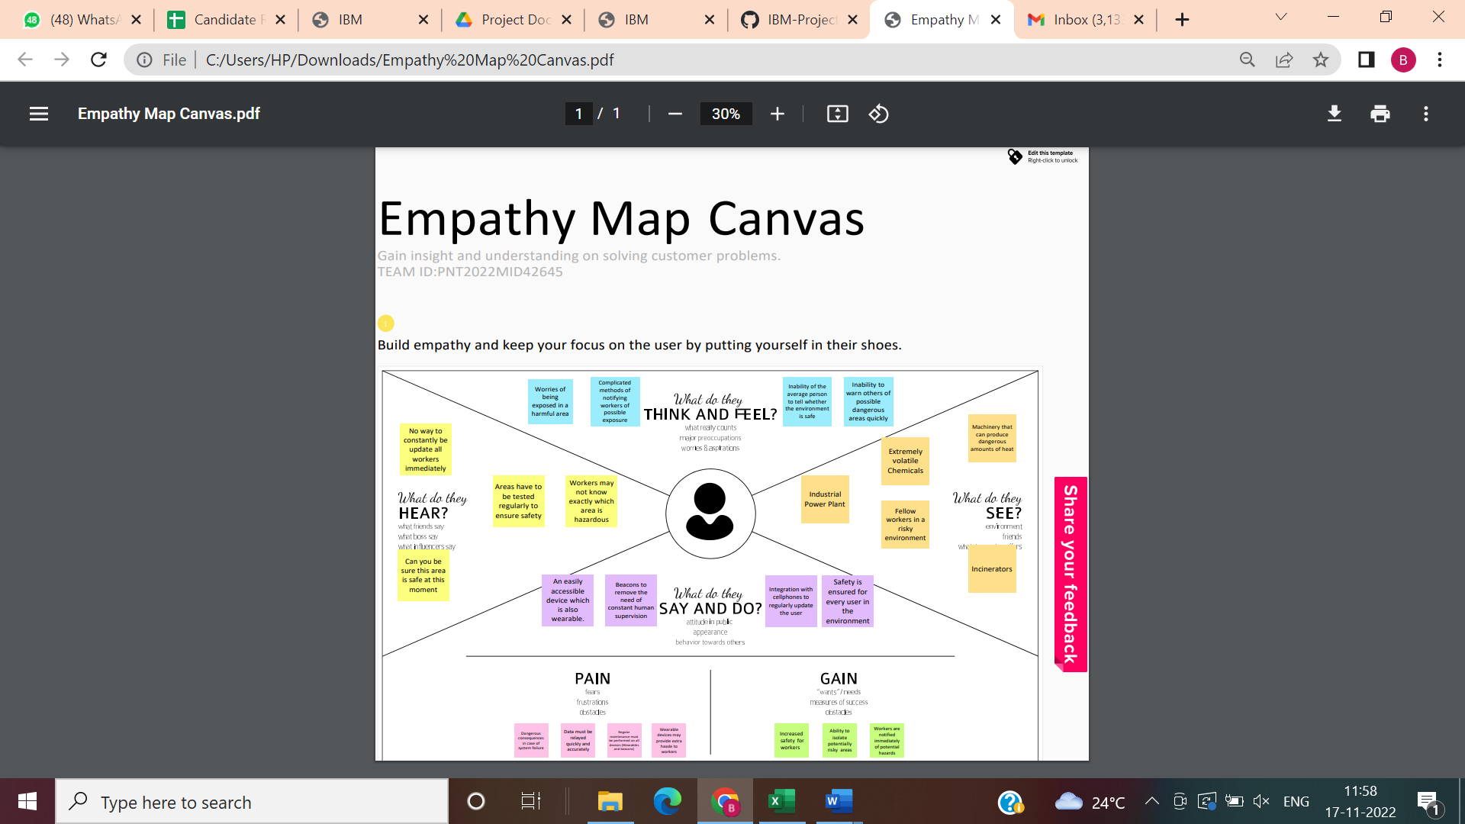



3.2 Ideation and Brainstorming

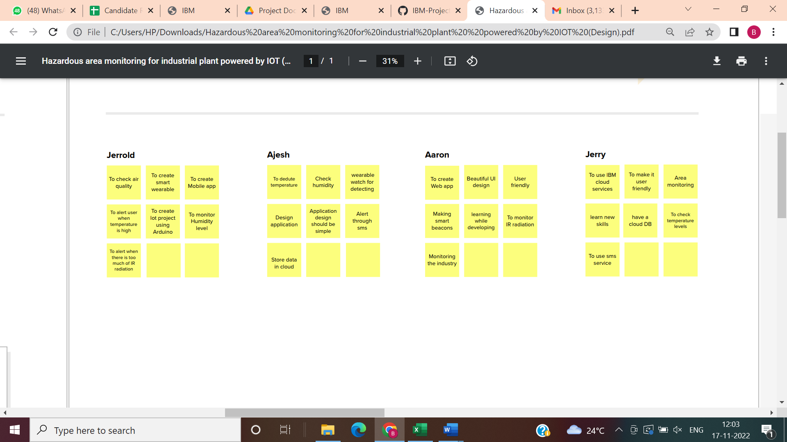

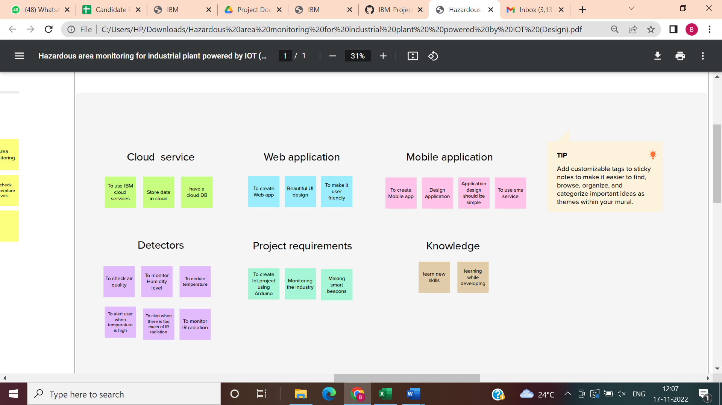

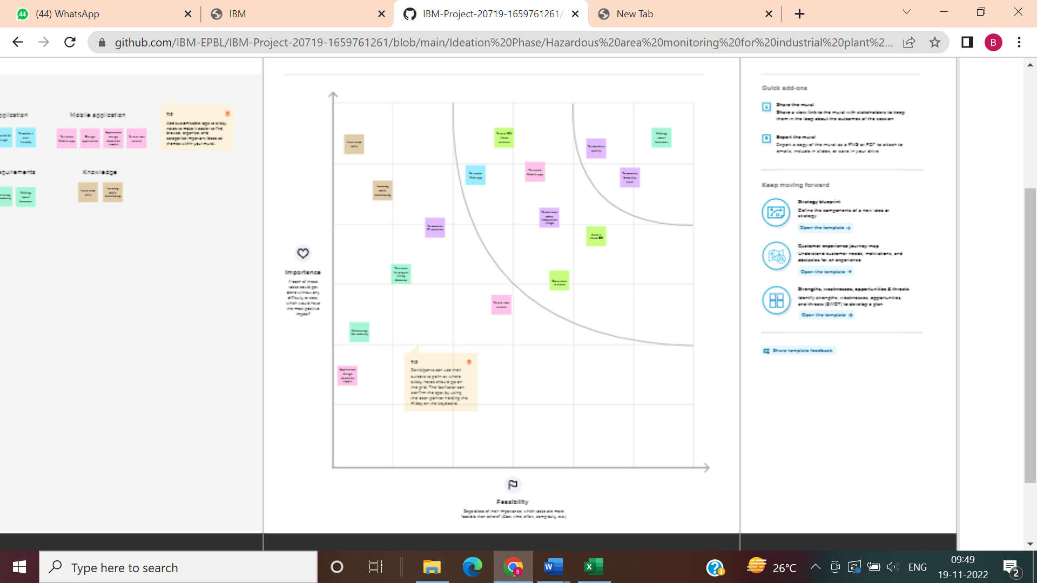

3.3 Proposed Solution

|  |  |  |
| --- | --- | --- |
| **S.NO** | **PARAMETER** | **DESCRIPTION** |
| 1 | Problem Statement (Problem to be solved) | To monitor the temperature in Industrial plants by using IOT enabled devices. |
| 2 | Idea/Solution description | Temperature sensor interfaced with a miniaturized microcontroller, with latest temperature sensor to monitors temperature and gases inside the plant. As all the workers in the power plant would be wearing a helmet, the device installed at the front of the helmet. Then it would have an ultrasonic sensor so there is a distance alert when the 2temperaturegoes beyond the actual operating temperature |
| 3 | Novelty/Uniqueness | The device will be compact, and microcontroller used is an ArduinoUNOrev3or Pyboard for utilizing advanced technology. Uses Infrared temperature sensor for monitoring temperature. Wi fi module to upload all the data to the cloud and maintain the daily data and for verifications. |
| 4 | Social Impact /Customer Satisfaction | It will be more efficient, compact, lower power utilization and repairable. The product will be more reliable and will make the industrial supervisor recommend to the other plant and organization that require such devices. |
| 5 | Business Model (Revenue Model) | The proposed design will be cheaper and be more efficient and effective for the prize the industry spend. |
| 6 | Scalability of the Solution | We product will include a Miniaturized MOS sensor for monitoring the gaseous fuel level inside the power plant. |

3.4 Problem Solution Fit

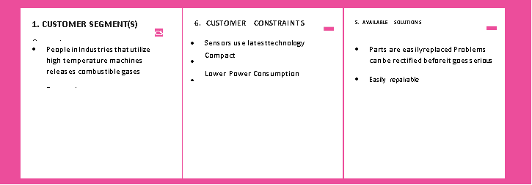





4. REQUIREMENT ANALYSIS

4.1 Functional Requirement

**Raspberry pi**

Raspberry Pi, developed by Raspberry Pi Foundation in association with Broadcom, is a series of small single-board computers and perhaps the most inspiring computer available today.

From the moment you see the shiny green circuit board of Raspberry Pi, it invites you to tinker with it, play with it, start programming, and create your own software with it. Earlier, the Raspberry Pi was used to teach basic computer science in schools but later, because of its low cost and open design, the model became far more popular than anticipated.

It is widely used to make gaming devices, fitness gadgets, weather stations, and much more. But apart from that, it is used by thousands of people of all ages who want to take their first step in computer science.

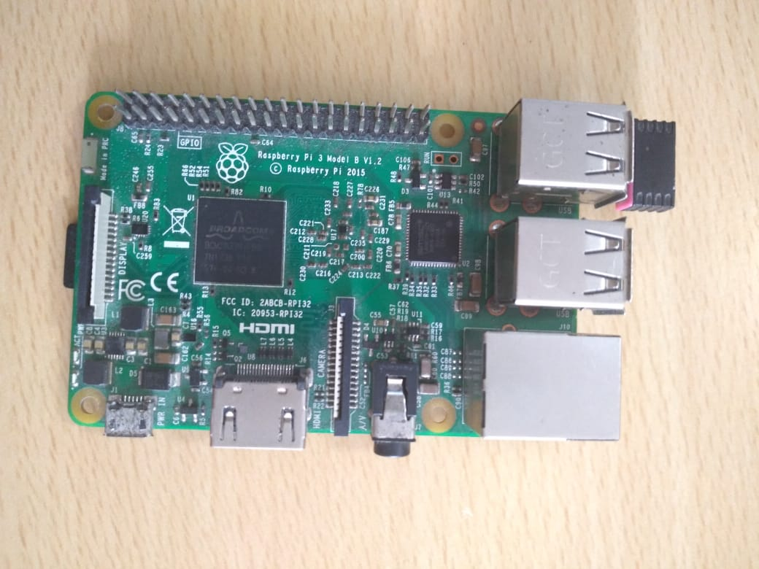

**DHT11 temperature and humidity sensor**

This DHT11 Temperature & Humidity Sensor features a temperature & humidity sensor complex with a calibrated digital signal output. By using the exclusive digital-signal acquisition technique and temperature & humidity sensing technology, it ensures high reliability and excellent longterm stability. This sensor includes a resistive-type humidity measurement component and an NTC temperature measurement component, and connects to a high performance 8-bit microcontroller, offering excellent quality, fast response, anti-interference ability and cost- effectiveness

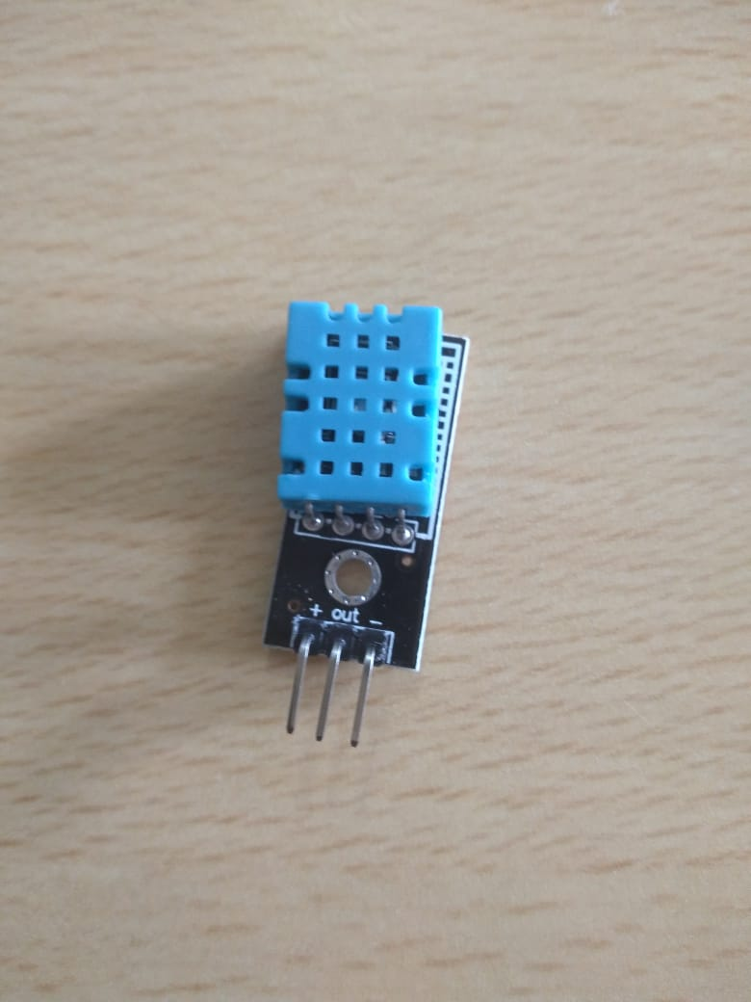

**ESP8266**

ESP8266 offers a complete and self-contained Wi-Fi networking solution, allowing it to either host the application or to offload all Wi-Fi networking functions from another application processor. When ESP8266 hosts the application, and when it is the only application processor in the device, it is able to boot up directly from an external flash. It has integrated cache to improve the performance of the system in such applications, and to minimize the memory requirements.

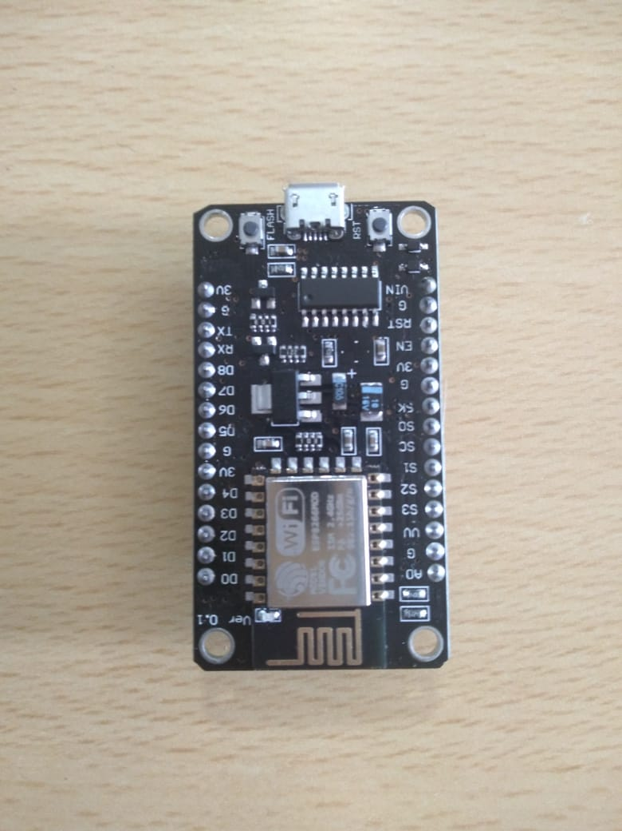

**Connecting wires (female to female) and Data cable:**

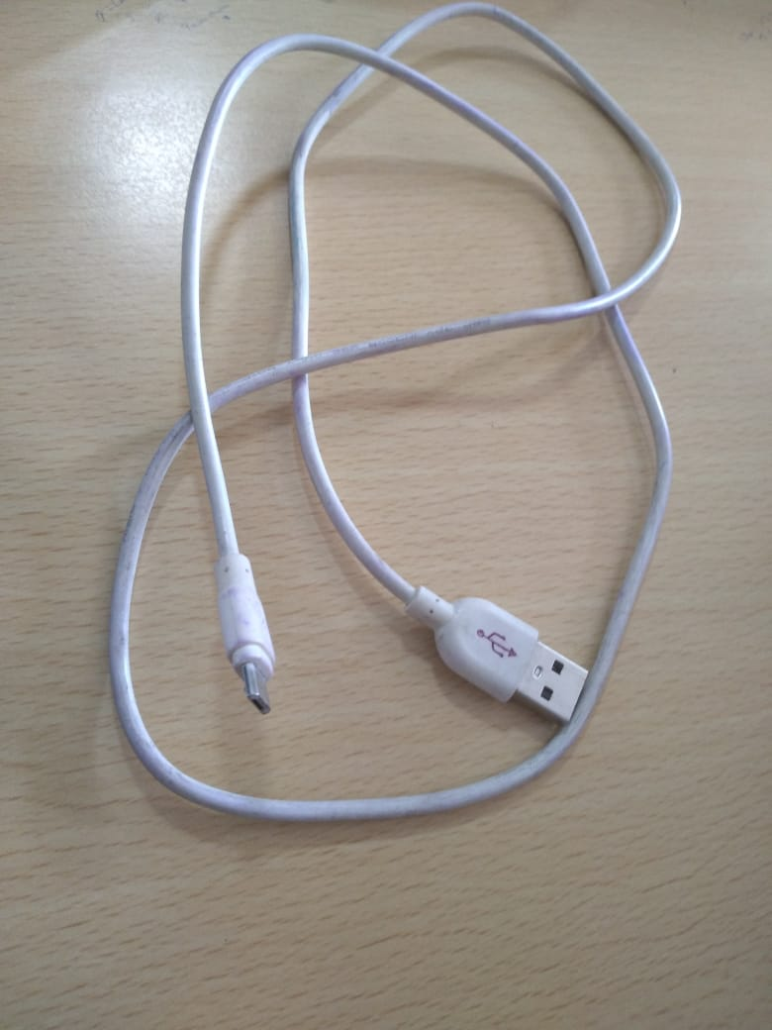 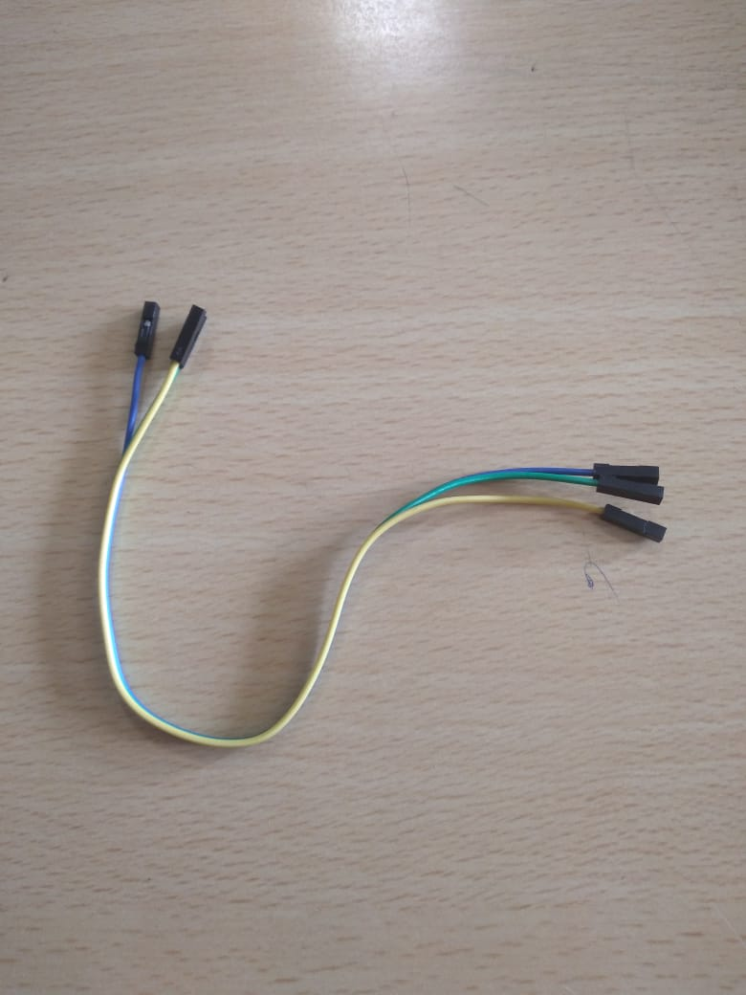

4.2 Non ­­- Functional Requirements

**▪ Arduino IDE:**

The Arduino Integrated Development Environment - or Arduino Software (IDE) - contains a text editor for writing code, a message area, a text console, a toolbar with buttons for common functions and a series of menus. It connects to the Arduino and Genuine hardware to upload programs and communicate with them.

**▪ IBM cloud:**

Responsible for all the communications between the smart phone and hardware. You can use our IBM Cloud. It’s open-source, could easily handle thousands of devices and can even be launched on a Raspberry Pi.

5.PROJECT DESIGN

5.1 Data Flow Diagrams

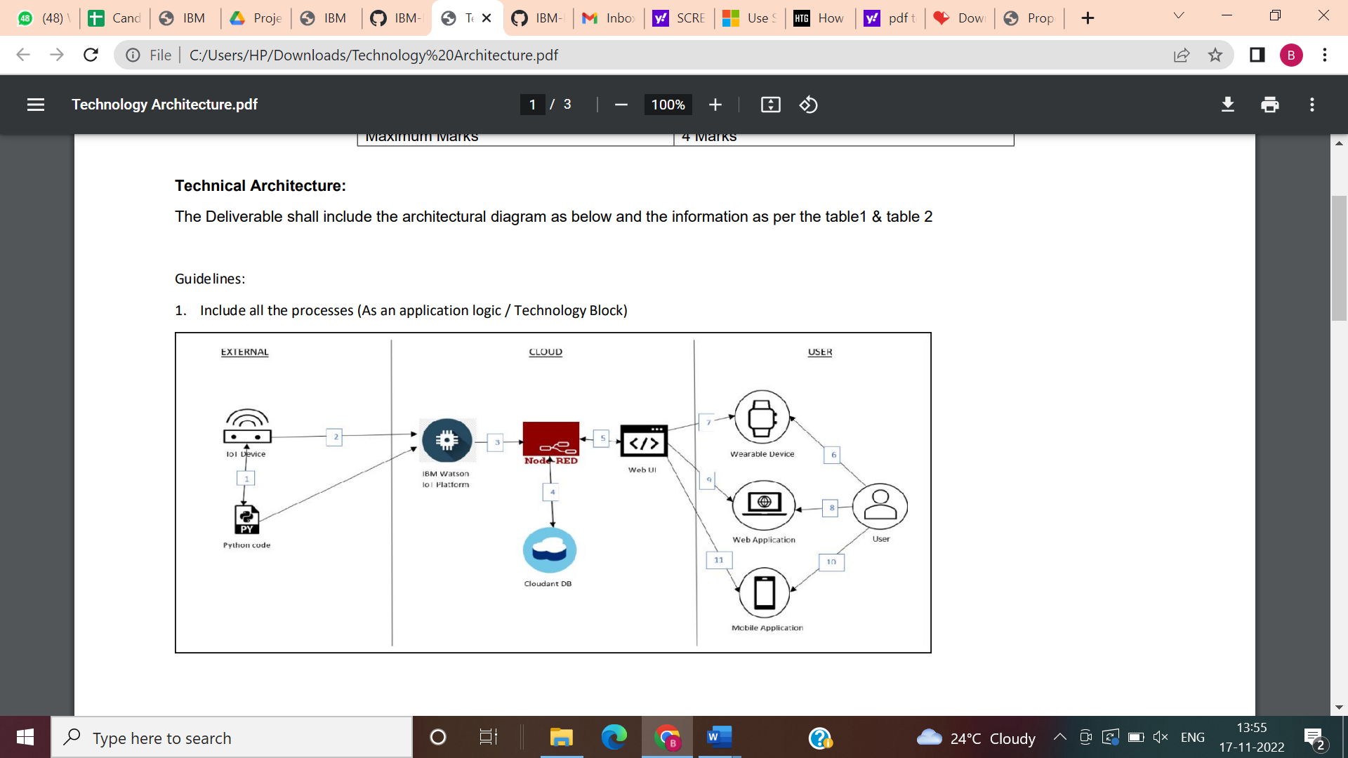

5.2 Solution and Technical Architecture

|  |  |  |  |
| --- | --- | --- | --- |
| **S.NO** | **Component** | **Description** | **Technology** |
| 1 | User Interface | User can interact with device using web application and through SMS | HTML, CSS, Java |
| 2 | Application Logic-1 | Get the temperature using sensor and send it to the microcontroller for analysis and compare with standard values | Java / Python |
| 3 | Application Logic-2 | Provide solution to monitor data and control the machine and units and provide API between user and devices | IBM Watson STT service |
| 4 | Database | The data will be temperature value at regular interval of time and the combustible gas levels | MySQL |
| 5 | Cloud Database | The measured data is sent to the cloud service using Wi fi module | IBM Cloudant |
| 6 | File Storage | Require an encrypted storage service among industry, workers and officers | IBM Block Storage, or Drop box, AWS |
| 7 | External API-1 | Purpose of External API used in the application | IBM Weather API, etc |
| 8 | External API-2 | Purpose of External API used in the application | Aadhar API, etc. |
| 9 | Machine Learning Model | Purpose of Machine Learning Model | Object Recognition Model, etc. |

**TABLE 2**

|  |  |  |  |
| --- | --- | --- | --- |
| **S.NO** | **Characteristics** | **Description** | **Technology** |
| 1 | Open-Source Frameworks | To create web application and circuit designing | App Inventor and Node-Red |
| 2 | Security Implementations | Each user should have their own credential to access data servers | Email and respective password |
| 3 | Scalable Architecture | Industrial 4.0, Internet of Things | Data Analytics, web service |
| 4 | Availability | 1. microcontroller with integrated Wi fi module to upload all the data to the cloud 2. Temperature sensor 3. monitoring the gaseous fuel level | Arduino UNO Wi fi or Pyboard or ESP8266 Infrared Miniaturized MOS sensor |
| 5 | Performance | Makes use of advanced sensors Distributed data service high efficient microcontrollers | Lower power consumption Longer range communication High speed data transfer |

5.3 User Stories

|  |  |  |  |  |  |  |
| --- | --- | --- | --- | --- | --- | --- |
| **User Type** | **Functional Requirement (Epic)** | **User Story Number** | **User Story / Task** | **Acceptance criteria** | **Priority** | **Release** |
| Engineering | Installation | USN-1 | The engineer must install the smart beacons helmet to ensure the entire unit is covered | The beacon must be available for maximum number of worker possible. | High | Sprint-1 |
|  | Data Gathering | USN-2 | The beacons obtain the temperature of the irrespective area using sensors. | The temperature of areas within the plant is obtained. | High | Sprint-1 |
|  | Data Sync | USN-3 | The beacons send their data to the cloud in the real time and the administrators dashboard. | Data is sent to the cloud successfully and synced with other devices. | High | Sprint-1 |
| Workers | Wearable device display | USN-4 | The wearable devices should display the data sent by beacons within the area. | The user can see the temperature of the area on their device. | High | Sprint-1 |
|  | Wearable device adjustments | USN-5 | The user can adjust the size of the wearable device to better suit them | The user can make adjustments to the device to make working with it more comfortable. | Low | Sprint-2 |
|  | Wearable display customization | USN-6 | The user can adjust the device display to suit their needs on the device itself. | The user can modify the display of the device to increase readability. | Medium | Sprint-2 |
|  | SMS Notifications | USN-7 | A notification is sent to the control room through an API key and work is alerted through notifications when the temperature raises beyond the actual working temperature | The user is informed of potential danger via SMS as soon as it is detected by the beacons. | High | Sprint-1 |
| Control Room Administrators | Admin Dashboard | USN-8 | The beacons send the data through the cloud toa dash board which is run by the administrator. | The data of all the beacons can be viewed by the administrator of the plant. | High | Sprint-1 |
|  | Dashboard Customization | USN-9 | The dashboard can be modified as per requirements the industry | The admin can customize the UI for their dashboard. | Medium | Sprint-2 |

6. PROJECT PLANNING AND SCHEDULING

6.1 Sprint Planning and Estimation

|  |  |  |  |  |  |  |
| --- | --- | --- | --- | --- | --- | --- |
| **Sprint** | **Functional Requirement (Epic)** | **User Story Number** | **User Story / Task** | **Story Points** | **Priority** | **Team Members** |
| Sprint-1 | Installation of Beacons | USN-1 | First the Admin will be installing smart beacons at necessary places. | 15 | High | Brinda Prakhasa Dharshini T  Monika J  Ilavarasan K  Balakrishnan S |
| Sprint-1 | Providing Wearables | USN-1 | The admin will be providing everyone at the Industry a wearable device | 5 | Medium | Brinda Prakhasa Dharshini T  Monika J  Ilavarasan K Balakrishnan S |
| Sprint-2 | Cloud Setup | USN-2 | The smart Beacons will connect with the cloud services. Where we can get the realtime data from the wearable | 20 | High | Brinda Prakhasa Dharshini T  Monika J  Ilavarasan K Balakrishnan S |
| Sprint-4 | Monitoring via Mobile | USN-4 | Mobile Application will be created and fast sms will be used to alert abnormality to the user | 20 | High | Brinda Prakhasa Dharshini T  Monika J Ilavarasan K  Balakrishnan S |

Project Tracker, Velocity & Burndown Chart:

|  |  |  |  |  |  |  |
| --- | --- | --- | --- | --- | --- | --- |
| **Sprint** | **Total Story Points** | **Duration** | **Sprint Start Date** | **Sprint End Date (Planned)** | **Story Points Completed (as on Planned End Date)** | **Sprint Release Date (Actual)** |
| Sprint-1 | 20 | 6 Days | 24 Oct 2022 | 29 Oct 2022 |  | 29 Oct 2022 |
| Sprint-2 | 20 | 6 Days | 3 1Oct 2022 | 05 Nov 2022 |  | 05 Nov 2022 |
| Sprint-3 | 20 | 6 Days | 07 Nov 2022 | 12 Nov 2022 |  | 12 Nov 2022 |
| Sprint-4 | 20 | 6 Days | 14 Nov 2022 | 19 Nov 2022 |  | 19 Nov 2022 |

Velocity:

Imagine we have a 10-day sprint duration, and the velocity of the team is 20 (points per sprint). Let’s calculate the team’s average velocity (AV) per iteration unit (story points per day)

6.2 Sprint Delivery Schedule

|  |  |  |
| --- | --- | --- |
| **TITLE** | **DESCRIPTION** | **DATE** |
| Literature Survey &Information Gathering | Literature survey on the selected project & gathering information by referring the, technical papers , research publications etc. | 20 SEPTEMBER 2022 |
| Prepare Empathy Map | Prepare Empathy Map Canvas to capture the user Pains & Gains, Prepare list of problem statements | 20 SEPTEMBER 2022 |
| Ideation | List the by organizing the brainstorming session and prioritize the top 3 ideas based on the feasibility & importance. | 30 SEPTEMBER 2022 |
| Proposed Solution | Prepare the proposed solution document, which includes the novelty, feasibility of idea, business model, social impact, scalability of solution, etc. | 13 OCTOBER 2022 |
| Problem Solution Fit | Prepare Problem Solution Fit document | 15 OCTOBER 2022 |
| Solution Architecture | Prepare Solution Architecture document | 20 OCTOBER 2022 |
| Customer Journey | Prepare the customer journey maps to understand the user interactions & experiences with the application (entry to exit). | 22 OCTOBER 2022 |
| Functional Requirement | Prepare the Functional Requirement document | 24 OCTOBER 2022 |
| Data Flow Diagrams | Draw the diagrams and submit for review | 26 OCTOBER 2022 |
| Technology Architecture | Prepare the technology architecture diagram. | 27 OCTOBER 2022 |
| Prepare Milestone & Activity List | Prepare the milestones &activity list of the project. | 30 OCTOBER 2022 |
| Project Development -Delivery of Sprint-1, 2, 3 & 4 | Develop & submit the developed code by testing it | IN PROGRESS. |

7. CODING AND SOLUTIONING

7.1 Feature 1

|  |
| --- |
| #include <dht.h> |
|  |  |
|  | #define dht_apin A0 // Analog Pin 0 is connected to DHT sensor |
|  | #define mqt_apin A1 // Analog Pin 1 is connected to MQT 135 sensor |
|  | dht DHT; |
|  | int sensorValue; |
|  |  |
|  | void setup(){ |
|  |  |
|  | Serial.begin(9600); //Serial port to communicate with Python code |
|  | Serial1.begin(9600); //Serial port to communicate with Wearable device through Bluetooth (HC-05) |
|  | delay(500); //Delay to let system boot |
|  | } |
|  |  |
|  | void loop(){ |
|  |  |
|  | DHT.read11(dht_apin); // read analog input pin 0(DHT11) |
|  | sensorValue = analogRead(mqt_apin); // read analog input pin 1(MQ135) |
|  |  |
|  | //Send Humidity status to Python Code |
|  | Serial.print("Current humidity = "); |
|  | Serial.print(DHT.humidity); |
|  | Serial.print("% "); |
|  |  |
|  | //Send Temperature status to Python Code |
|  | Serial.print("temperature = "); |
|  | Serial.print(DHT.temperature); |
|  | Serial.println("C "); |
|  |  |
|  | //Send AirQuality sensor value to Python code |
|  | Serial.print("AirQua="); |
|  | Serial.print(sensorValue, DEC); |
|  | Serial.println(" PPM"); |
|  |  |
|  | //Send signals to the Wearable |
|  | Serial1.println("H T A"); |
|  | Serial1.println(DHT.humidity); |
|  | Serial1.println(DHT.temperature); |
|  | Serial1.println(sensorValue, DEC); |
|  |  |
|  | delay(100); // wait 100 milliseconds for next reading |
|  | } |

8. TESTING

8.1 Test Cases

|  |  |  |  |  |  |  |  |  |  |
| --- | --- | --- | --- | --- | --- | --- | --- | --- | --- |
|  | | | NFT - Risk Assessment | | | | |  | |
| S  No | Project Name | Scope/feature | Functional Changes | Hardware Changes | Software Changes | Impact of Downtime | Load/Volume Changes | Risk Score | Justification |
| 1 | Hazardous area monitoring in industrial plants | Existing | No Changes | No Changes | Moderate | Same | Based on temperature | Alert sent to mobile | As we have seen the changes |
| 2 | Hazardous area monitoring in industrial plants | Existing | No Changes | No Changes | No Changes | Same | Based on temperature | Alert sent to mobile | As we have seen the changes |
| 3 | Hazardous area monitoring in industrial plants | Existing | No Changes | No Changes | No Changes | Same | Based on temperature | Alert sent to mobile | As we have seen the changes |
| 4 | Hazardous area monitoring in industrial plants | Existing | No Changes | No Changes | No Changes | Same | Based on temperature | Alert sent to mobile | As we have seen the changes |
| 5 | Hazardous area monitoring in industrial plants | Existing | No Changes | No Changes | No Changes | Same | Based on temperature | Alert sent to mobile | As we have seen the changes |

8.2 User Acceptance Testing

# Purpose of Document

The purpose of this document is to briefly explain the test coverage and open issues of the Harzardous Area monitoring in industrial plants project at the time of the release to User Acceptance Testing (UAT).

# Defect Analysis

This report shows the number of resolved or closed bugs at each severity level, and how they were resolved

|  |  |  |  |  |  |
| --- | --- | --- | --- | --- | --- |
| **Resolution** | **Severity 1** | **Severity 2** | **Severity 3** | **Severity 4** | **Subtotal** |
| By Design | 1 0 | 4 | 2 | 3 | 20 |
| Duplicate | 1 | 0 | 3 | 0 | 4 |
| E External | 2 | 3 | 0 | 1 | 6 |
| Fixed | 1 1 | 2 | 4 | 20 | 37 |
| N Not Reproduced | 0 | 0 | 1 | 0 | 1 |
| S Skipped | 0 | 0 | 1 | 1 | 2 |
| Won't Fix | 0 | 5 | 2 | 1 | 8 |
| Totals | 2 4 | 14 | 13 | 26 | 78 |

# Test Case Analysis

This report shows the number of test cases that have passed, failed, and untested

|  |  |  |  |  |
| --- | --- | --- | --- | --- |
| **Section** | **Total Cases** | **Not Tested** | **Fail** | **Pass** |
| Print Engine | 7 | 0 | 0 | 7 |
| C Lient Application | 5 | 0 | 0 | 5 |
| Security | - | - | - | - |
| Outsource Shipping | - | - | - | - |
| Exception Reporting | 1 | 0 | 0 | 1 |
| Final Report Output | 4 | 0 | 0 | 4 |
| Version Control | - | - | - | - |

9. RESULTS

9.1 Performance Metrics

The project developed will be very useful to many customers like safety manager, manufacturing unit owners and even helpful for the workers working in hazardous area.

The data is sent when there is change in temperature than the desired level.

The data is sent to 100 devices at a time and the number of devices can be altered.

Even the continuous monitoring of the temperature can be done. The accuracy is also high.

10. ADVANTAGES AND DISADVANTAGES

As the coin has two sides, this device also has both advantages and disadvantages. The major advantage is that the continuous monitoring of devices and can be monitored by more than 100 persons. But the major disadvantage is that the need of network facility to transfer data.

11. CONCLUSION**:**

IoT enabled industrial monitoring system has been a wide requirement in various industries as they raise the safety standards exponentially whilst providing a real time monitoring of critical parameters like temperature, humidity, pressure etc. and notified regularly to concerned officials/ workers. The Implementation is not only in the view of safety but also could be used as a yield booster for the industry.

12.FUTURE SCOPE**:**

This project based on IoT can be further expanded by providing additional facility to the industry person with the help of Android app for achieving better control and monitoring of industry. Further, smoke and gas sensors can be interfaced with the system to ensure security of industry workers and goods in case of fire or toxic gas leakage

1. APPENDIX

PIN CONFIGURATION OF TEMPERATURE SENSOR DHT11:

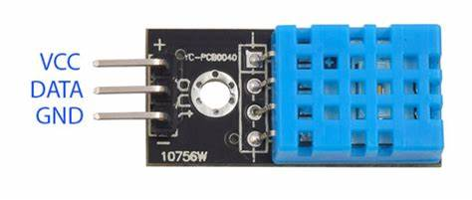ESP8266 PIN CONFIGURATION:

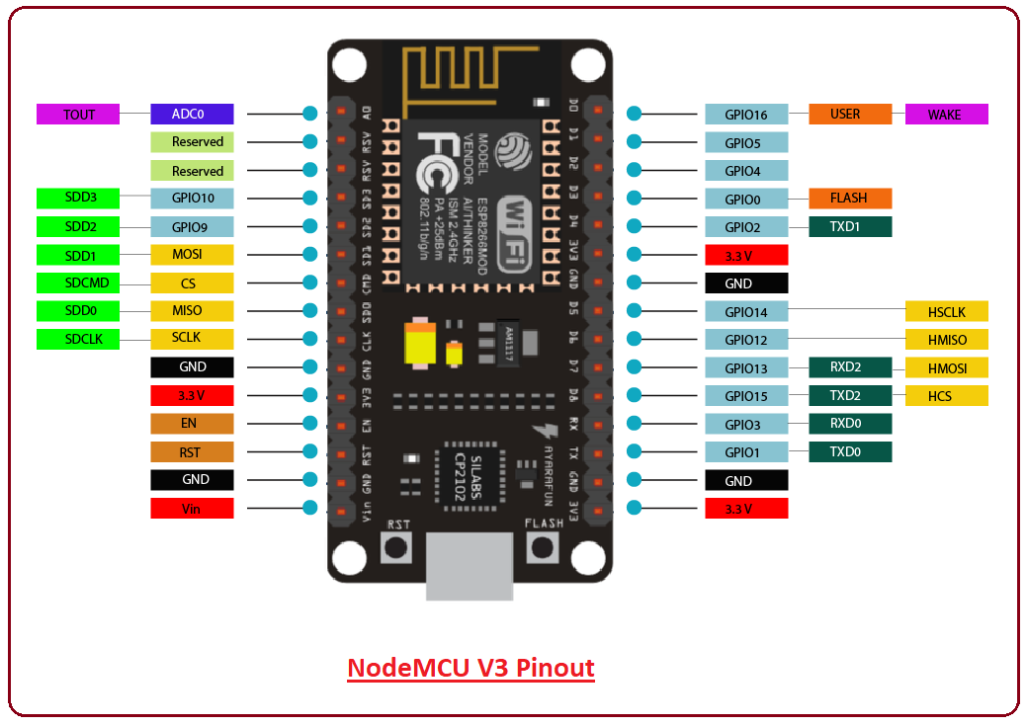

GITHUB LINK:

<https://github.com/IBM-EPBL/IBM-Project-20719-1659761261>



PROJECT DEMO LINK:

<https://youtu.be/u6YBIZ0wR3Y>

